Year 6
LEADERSHIP
CHALLENGE
2015

RATIONALE

The Year 6 students are now the leaders of the student body at Guardian Angels. The younger students look up to these young people for guidance, assistance and as role models. The teaching and administration team would like to offer the students the opportunity to take on leadership roles within the school as well as develop their independence, teamwork skills, confidence and organisational skills - building the backbone for their success in high school and beyond.

Leadership Challenge / Angels Challenge

Yr. 6 students have the opportunity to attain 2 badges:

- The Leadership Badge (Term 1)
- The Year 6 Angels Challenge ‘Victory’ Badge (End of Term 3)

This year, tasks and expectations have changed and the all Year 6 students will be given their Leadership Badges in Term 1. Year 6 student leaders may proudly wear this for the year, as long as they are fulfilling their leadership duties as outlined on the following pages.

Students who are not displaying Leadership standards will lose their Leadership Badge until they can demonstrate the desired standard as required by the staff of Guardian Angels.

Students must attain their Year 6 Angels Challenge Badge, in order to demonstrate leadership and keep their Leadership Badge. This demonstrates commitment to keeping on the Angels Challenge journey through the years and provides great role modelling for the younger Guardian Angels students.

Leadership has been described as "a process of social influence in which a person can enlist the aid and support of others in the accomplishment of a common task". For example, some understand a leader simply as somebody whom people follow, or as somebody who guides or directs others, while others define leadership as "organizing a group of people to achieve a common goal".

Leadership Requirements:

The classroom teachers will monitor the student’s involvement within 3 areas;

- Citizenship
- Academic Application
- Life Skills

*** Citizenship***

- Students are given an area/leadership job for the whole year. They form part of a team that ensures their allocated role is maintained throughout the year. The year 6 spare room is HQ, where team job roles are displayed and folders/equipment kept.
- Students record their contribution/involvement in school events (e.g. fundraisers, charity, mass)

Leadership Teams & Role Description

- House Captains

- Band Leaders

- Peer Mediators

- Green Warriors

- Function Crew

- Assembly IT Team

- Media Crew

- Flag Bearers

- Junior Librarians

- Justice Crew

*** Academic Application ***

Students will, as part of their preparation for high school, endeavour to fulfill requirements in the pursuit of the following;
* Positive study habits
* Time management skills
* Concept mastery / concept consolidation
* Reading for enjoyment

Requirements

- A neat and organized diary that comes to school each day and is signed by parent weekly and checked by classroom teacher each Tuesday.

- A maintained and active reading log. The goal is to read 200 nights by the end of the year to be part of the 200 Club. All students who have read for 150 nights by end of Term 3 will be eligible for their Angels Challenges badge in the last week of Term.

- Completion of tasks and assignments that are set for both school and home. Tasks for home are not regimented (no weekly homework sheet) but do give students who have missed class/lessons or haven’t produced the desired amount or standard work, responsibility to follow through in their own time. There can also be extension activities for keen students looking for more challenging activities.

- Writing Tasks – creating and editing at school and home. Due dates must be adhered to and writing shared with class or dropped on WIKI to use as shared reading. This system is intended to enhance the editing stage of writing. Students need to ask themselves, “ Is it my best work? How could I make it better?” before sharing their writing.

Remember:
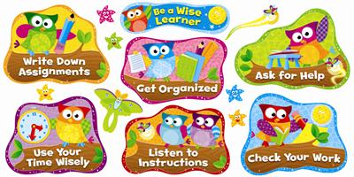
Good writers write. Good writers write all the time.

*** Life Skills ***

Teacher will set challenges that enhance student life skill attainment.
These challenges can be set weekly, monthly or as teachers see fit. Challenges may be general for the whole class or specific for gender or purpose. They may reflect curriculum being taught in classroom.

Examples

- Basic First Aid
- Play is the Way – Resilience Program
- Cooking / Garden – Stephanie Alexander Garden Program
- Community Service
- Cyber Safety
- Road Safety
- Shopping Skills (mathematics – money, measurement)
- Communication / People Skills - Interview a senior resident of your community (neighbour) – covering the meet and greet (handshake), confidence, eye contact, questioning.
- Chivalry / Etiquette – Male respect for women, general etiquette in society.
- Creativity – web design, APP design
- Music Appreciation
- General Knowledge – Current Affairs / World News

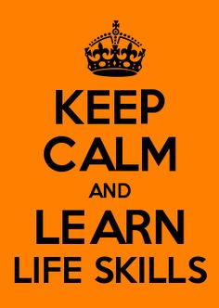

Annual Citizenship Awards

On Graduation Night, two awards are given to one female and one male Year 6 student that hold great prestige and tradition at Guardian Angels. The Pat Otago (female) and John Maksimas (male) trophy are awarded to two members of the graduating class who have consistently demonstrated the most outstanding examples of citizenship and leadership. The Leadership Challenge is designed to assist students in demonstrating the necessary qualities required to be a recipient for this award, as well as developing exceptional life-skills.

