Junior Angels Challenges P-2
About the Junior Angels Challenges P-2:
This is an exciting area of learning which we invite all P - 2 students to participate in. It provides a sense of fun, wonder, self worth, community, uniqueness, entrepreneurship – the list is endless. Gone are the days where teachers are sending home ‘work’ that imposes on your busy family lives, can cause unnecessary tears, stress and sometimes arguments – rather we have these challenges that are merely an extension of a child’s learning.

Junior Angels Challenges contain 5 categories:
- Helping Challenge.
- Creative Challenge.
- Literacy Challenge.
- Numeracy Challenge.
- Active Challenge.

Children, with their carers, are required to devise 15 challenges over the course of the year. This means that children complete 5 challenges per term – 1 challenge for each of the 5 categories for 3 terms. These 5 challenges per term must be sighted and signed off on by the teacher by the end of each term. A Record Sheet will be given to the children for recording the challenge activity, which will be kept in this Junior Challenge Folder as evidence per term.
The challenges are designed so that the children can work towards achieving a goal. By completing the challenges our wish is that the children will develop a sense of achievement and pride. For example, a task such as making a bed should not just stop at one week but should continue for every day of the term and a record of completion must be attained (e.g. journal, diary, checklist etc). Whereas a task such as writing a song or story should be completed over a couple of days, and that evidence will be placed in this folder.. Your judgement of your child’s ability will determine the degree of difficulty and a reasonable but challenging amount of learning needs to occur. The tasks should challenge the child’s ability, yet be achievable. These challenges are designed for children to have a lot of positive experiences that help others while building on their knowledge, skills and creativity.
Junior Angels Challenges P-2: Suggestions
Helping Challenge  - Set a table.  - Clean a room.  - Make a bed.  - Garden/weed.  - Sweep.  - Learn how to tie your shoelaces.  - Environmental challenge (see website for ideas).  - Design your own. | Choose one challenge from each section and document it on the Record Sheet.  There will be one per term. | Creative Challenge  - Make something.  - Paint a picture.  - Cook something.  - Sing a song.  - Write a poem.  - Design your own.
Literacy Challenge  - Retell a book or a movie.  - Write a book.  - Share a book/letter/poem/song.  - Listen to stories on a CD.  - Japanese Hiragana Challenge (see website or Japanese wiki for details for your year level).  - Design your own. | Numeracy Challenge  - Make a timetable.  - Shop with real money and use a budget.  - Keep a height chart.  - Keep a calendar/schedule.  - Make a clock and try to learn how to tell the time.  - Design your own. | Active Challenge  - Participate in afterschool activities, e.g. Dancing, Swimming, Sport, Drama.  - Go for a bush/beach walk with your family  - Active travel to school once per week for a term – walk with the Walking School Bus, ride your scooter or bike etc.  - Play outside, e.g. 1 afternoon per week.  - Design your own.

Junior Angels Challenges P-2: Record Sheet
Name:_____________________________________ Term: ____________ Class: ______________
Helping Challenge | 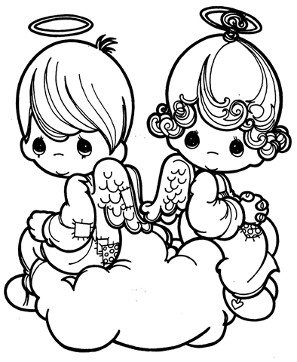  Write the challenge completed in the relevant box. Please provide evidence when submitting your record sheet. Evidence can be in the form of writing, drawing, photographs, diary entry, etc. | Creative Challenge
Literacy Challenge | Numeracy Challenge | Active Challenge

