A Journey of Learning

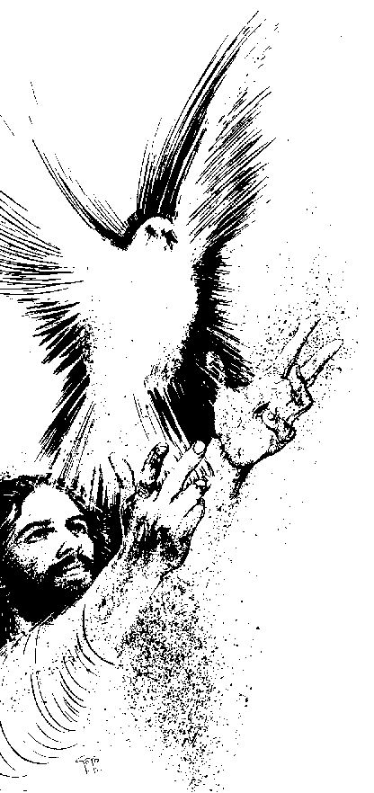

Twenty and Thirty Years of Service
to Catholic Education
2010

. . . . YOUR SCHOOL NAME HERE . . . .

Opening Rite

Prayer Leader: We begin by welcoming the presence of the Spirit of Jesus among us in the lighting of the candles……(Pause)……and the eternal, faithful presence of our God who walks with us, in the opening of the Book of The Word ………..(pause)

Let us proclaim what we believe, by making the sign of the cross:

All: In the Name of the Father, and of the Son and of the Holy Spirit. Amen.

Prayer Leader: We gather in God’s presence to acknowledge twenty and thirty years of dedication, generous service and faithful witness to the Good News of Jesus by our colleagues ……..(names). We thank them for the unique gifts they have brought to Catholic Education in this and many other places of education in our Archdiocese, this state, country and throughout the world in the past twenty years. Let us thank God for their presence among us and seek the continued presence of the Spirit in their work:

All: Loving God, you reach out to all of your creation through us, as we proclaim your dream to the world by the way we live and work and play. We thank you for the twenty years of dedicated service of the colleagues we honour today. We ask for your gentle and loving Presence with them now and always, as they seek to bring the light of learning, justice, peace and compassion to the lives of all they meet.
We make our prayer in the name of Jesus, who sends us out to the whole world to proclaim your love for us all.
Amen.

Proclamation of the Word

Reader: A reading from the Good News according to Luke (4:14-19).

Jesus returned in the power of the Spirit to Galilee and his reputation was spreading throughout the region. He was teaching in their synagogues and all were loud in his praise. He came to Nazareth where he had been reared and, entering the synagogue on the Sabbath as he was in the habit of doing, he stood up to do the reading. When the book of the prophet Isaiah was handed to him, he unrolled the scroll and found the passage where it was written:
‘The spirit of the Lord is upon me; therefore he has anointed me. He has sent me to bring good news to the poor, to proclaim liberty to captives, recovery of sight to the blind and release to prisoners; to announce a year of favour from the Lord.’

Rolling up the scroll, he gave it back to the assistant and sat down. All in the synagogue had their eyes fixed on him. Then he began by saying to them, ”Today this scripture passage is fulfilled in your hearing”. All who were present spoke favourably of him; they marvelled at the appealing words which he spoke.

The Gospel of the Lord

All: Praise to you, Lord Jesus Christ.

Shared Reflection on the Word (if desired)

Response to the Word

Prayer Leader:
Called, as we are, to follow Jesus’ model to proclaim good news to a world so often captive to the forces of despair, violence and injustice, let us ask for God’s transforming power in our lives.

Reader: Let us seek the powerful presence of God’s Spirit in our school, so we will fearlessly live out our call to model justice, compassion and peace. For this we pray….

All: Hear and answer us, O God.

Reader: With gratitude, we put before our God the lives and work of our colleagues who have worked for the fulfilment of Jesus’ vision for our world for twenty years. That our acknowledgement of their dedication will encourage them to continue in the Mission, we pray….

All: Hear and answer us, O God.

Reader: For all who work for and support the ministry of Catholic Education throughout the world: that we will daily remember our mission to proclaim God’s love to all we encounter. For this we pray…

All: Hear and answer us, O God.

Reader: On this special occasion when we celebrate dedication and service, we remember the community we serve: our students and their families. That their lives will be transformed by the compassion and justice and acceptance they experience among us. For this we pray…

All: Hear and answer us, O God.

Prayer Leader:
God of all that is good and just, give us the strength of your constant
presence, so that we can continue our mission of service in this time and
place. We make our prayer in Jesus’ name.

All: Amen.
Presentation to Special Guests

Prayer Leader: I now call on our colleagues, whom we honour today for their twenty and thirty years of service to Catholic Education, to come forward to receive this acknowledgement of their dedication to our students and their families.

Presentation of candles and certificates.

Response by Spokesperson for Special Guests (if desired)

Closing Rite

Rededication to Mission and Final Blessing

Prayer Leader: Inspired by the dedication of the people we have honoured and thanked today, I invite everyone present to rededicate our lives and work to the mission of service and witness to which we are all called.

Prayer Leader: Members of the community of ……………………., are you willing to continue in your service of the gospel and the mission given to us by Jesus?

All: We are!

Prayer Leader: Members of the community of……………………. are you willing to take Jesus as your model and guide in life and dedicate your lives to God’s service, as he did?

All: We are!

Prayer Leader: Members of the community of…………………., are you willing to work together with justice, compassion and peace so that all who encounter this community will feel welcome and loved by God?

All: We are!

Prayer Leader: Then may our companion God go with us and may we feel and know the presence of the Father, Son and Holy Spirit in our lives now and always!

All: Amen.

Prayer Leader: Let us go in peace, to continue the work God has begun in us.

All: Thanks be to our God!

