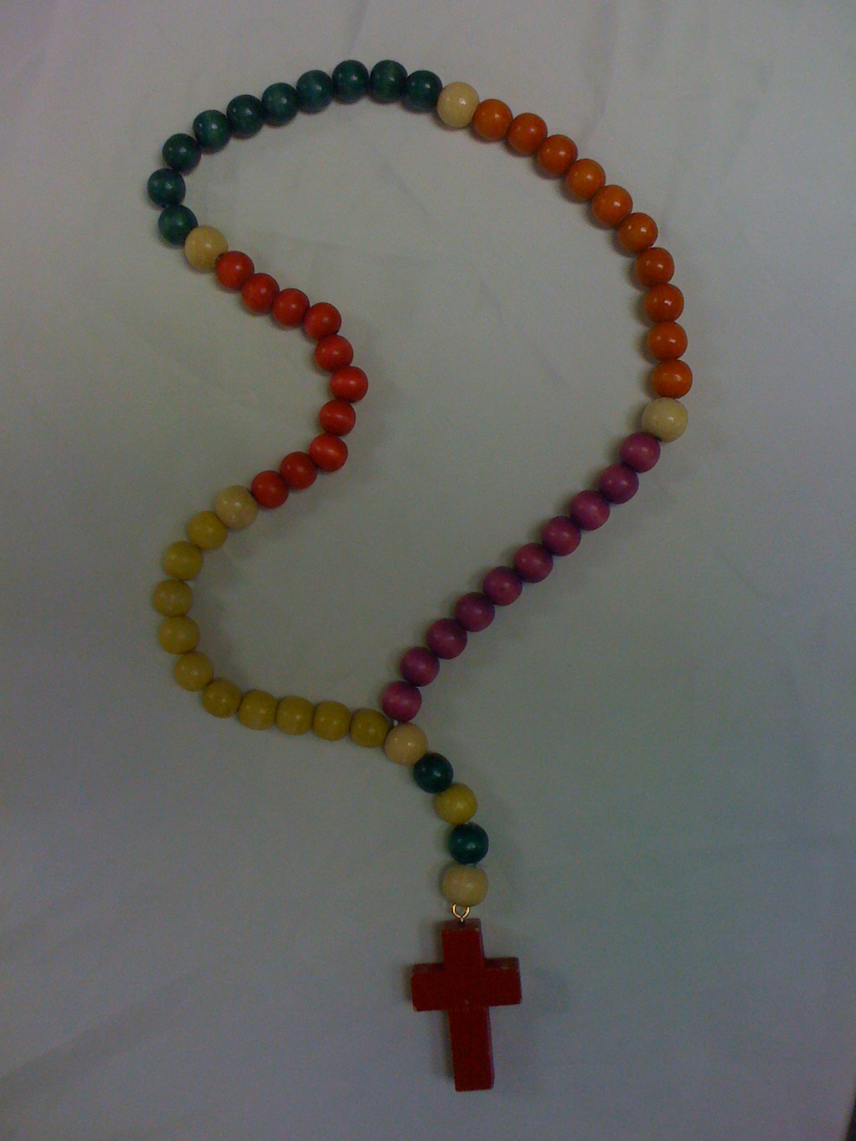
The Rosary

The Rosary is a meditation on the life of Jesus and Mary and was developed as a breathing prayer. The Rosary is a mantra; a centering prayer involving the repetition of a particular word or phrase as part of one’s breathing pattern. The words become less important when a place of inner silence and stillness is reached. It can be calming like a chant.

A suggested time for a focus on the Rosary is the month of October as the feast of the Holy Rosary is on October 7th. Another suitable time for a Rosary focus would be during the month of May. Depending on age and stage appropriateness, students may be able to pray one Hail Mary each morning/once a week or with older students to pray a decade of the Rosary:
1 Our Father
10 Hail Marys
1 Glory Be.

The Scripture story that goes with each of the decades could be told or read e.g. the Joyful Mysteries as in the Annunciation, the Visitation, the Birth of Jesus, the Presentation in the Temple and the Finding of the Child Jesus in the Temple. One mystery could be the focus for a week. Staff prayer during October could be a time to pray the Rosary.

History of the Rosary:
- The name comes from the Latin word rosarium which means ‘rose garden’.In the Middle Ages, Mary was often called ‘Rose’ and the name eventually became rosary.
- In olden times, people who couldn’t read or write couldn’t say the official prayer of the Church which consists of the 150 psalms of the Bible. So they replaced the psalms with 150 and then 50 Ave Marias / Hail Mary's and they used bags of pebbles to count them. They then used beads on a sting or knots tied in a cord. In between the decades the priests used to preach to the people about the happenings in the lives of Jesus and Mary.
- Saint Dominic – first historical reference to the rosary is from the life of Dominic (+1221) the founder of the Dominicans.
- Major religions have for centuries advocated the use of prayer beads as an aid to prayer. Since the earliest of times, people have used pebbles or a string of knots or beads on a cord to keep track of prayers offered to God. Muslims use a set of 99 beads with each bead representing a name for God in the Islamic faith tradition. Other examples are the Hindu “Mala beads’” and the Buddhist prayer beads.

The Mysteries

The Joyful Mysteries
The Annunciation
The Visitation
The Birth of Jesus
The Presentation in the Temple
The Finding of the Child Jesus in the Temple.

The Sorrowful Mysteries
1. The Agony in the Garden
2. The Scourging
3. The Crowning with Thorns
4. The Carrying of the Cross
5.The Crucifixion

The Glorious Mysteries
1.The Resurrection
2. The Ascension
3. The Descent of the Holy Spirit
4. The Assumption of Mary into Heaven
5.The Coronation of Mary

The Mysteries of Light
1. The Baptism of Light
2. The Wedding at Cana
3. The proclamation of the Kingdom of God – Jesus preaches to the crowds
4. The Transfiguration
5. The Last Supper

- The Mysteries of Light:
The late Pope John Paul II proclaimed a Year of the Rosary in 2002 stressing that this prayer is especially powerful as a petition for peace and the health of the family. The terrorist attacks on Sept 11th 2001 prompted him to call us to pray the rosary daily; for our families and for world peace. Pope John Paul said “the Rosary has a peaceful effect on those who pray it, leading them to see the face of Christ in others, to recognise other’s grief and to yearn to make the world more beautiful, more just, more closely conformed to God’s plan.” He added the Mysteries of Light which focus on episodes from Christ’s public ministry.

Creative ways to teach about and pray the Rosary

Read the story from scripture. Older students could locate the references. Retell the story in a variety of ways and describe the behaviours and feelings of a character in the text e.g. the boy Jesus in the temple.

- Lead students to enter “into" the scene of the particular mystery imagining the sights, smells, sounds, and emotions that Jesus, Mary, Joseph, and other participants experienced during the actual events.

- Respond to the mysteries by “doing” e.g. The Agony in the Garden – make a poster that reminds us of the needs of people who are suffering. The Visitation – visit a younger class to share songs or games or prayer. The Crowning of Mary as Queen of Heaven and Earth – write a prayer/litany or poem honouring Mary. The Baptism of Jesus – bring a photo of your Baptism

- Make sets of Rosary beads. Younger children could use large beads and make a rosary bracelet with one decade. Younger children could have turns at holding the beads while the class prays the Hail Mary.

- Make sets of rosary beads (one decade) as a Mother’s day gift. Include a book mark with directions of how to pray one decade of the Rosary and the words of the prayers. Students could be encouraged to teach their family about the rosary and how to pray one decade.

- Make connections between situations and contexts in Mary’s life and those of today. e.g. the Birth of Jesus and my birth.

- Create a PowerPoint presentation of one of the 4 mysteries depicting scriptural references and using artwork found on the web.

- Sequence the mysteries and make a Class Big Book. Students illustrate after being exposed to examples of sacred art. Write a simple summary of the story or a prayer.

- Create a Living Rosary: a rosary made of people instead of beads; candles, incense and soft music; a circle of prayer.

