ACKNOWLEDGMENT

This Retreat Program is part of a greater number of documents which have been generously supplied by a small number of schools prepared to share their resources and ideas with other schools for the benefit of students elsewhere.

This site is a growing space: If you find some of the ideas helpful, it would be wonderful if you could include your retreat/s in the Religious Education Leaders’ Collaborative Space.

Special thanks go to the following people for submitting these initial retreats:

Dana Wedge (St John Fisher College, Bracken Ridge)
Paul Towler (St Laurence’s College, South Brisbane)
Sandra Allen (Clairvaux-McKillop College, Mt Gravatt)
Jenny Cross (South Burnett Catholic College)
Alison Stone (Mt Alvernia College, Kedron)
Carmel O’Brien (Unity College, Caloundra)

 | St Laurence’s College  facere et docere  Year 11 Kairos – pan, scan, plan

KAIROS - a sacred time; a time apart
12 November 2007

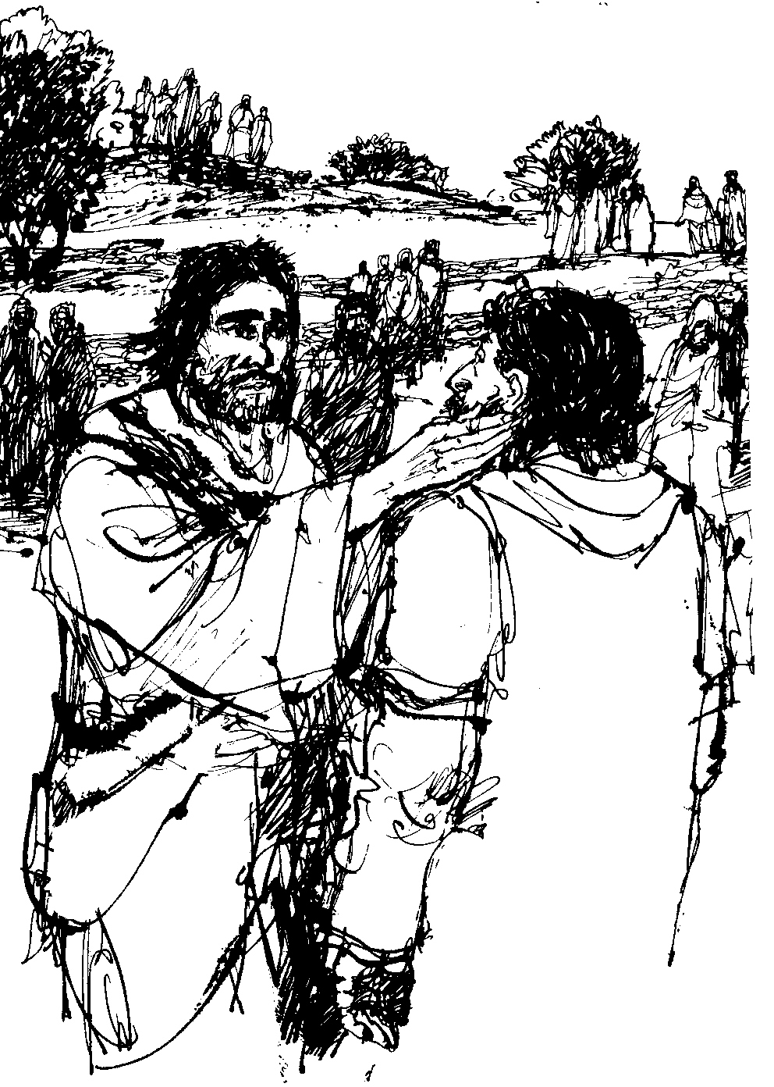

Name ..................................... H C Teacher & House ……………………….

St Laurence’s College
facere et docere

Year 11 Kairos 2007

[Note the work done on Spirituality of Leadership from Year 11 camp. This included:
- Rationale for leadership Kairos
- Outline of five styles of Spirituality of Leadership – Crowther
- Balance in my leadership style by expression with six pillars of the College]
It focuses on the core question: What need I to do now in order to experience the depth of achievement [and sense of grief at leaving] that Year 12’s experience at the College farewell?

Rationale

This Kairos session seeks to:

- Offer a contemplative or alternative prayer experience. Connecting to the sacred through solidarity with, learning from, service to the poor, vulnerable.

- Build on the Sole Ed – Bartimaeus program by reflecting on learnings from this; preparing students for contribution over the six checkpoints from now til this time next year both in and beyond curriculum and engaging in physically oriented, goal-setting, ‘cost’ awareness strategies.

- Re-name the five types of leadership and the six College pillars – please note service has been added. This should emphasise the 2008 Year 12’s leadership privilege of being the group in Year 11 and 12 to move forward a special focus on Servant leadership to the poor and vulnerable within the curriculum and with outside school hours next year. This session may wish to emphasise either balance or at least contribution in a number of areas or follow Marcus Buckingham’s theory of building on strengths.

- Offer a long term vision of Edmund Rice education by considering person’s contemporary ministries world-wide and invite student interest in exploring their own contribution

Program
Groups | Callan, Rice, Hogan I | Killian, Sion, Hogan II |  | Duhig, Nagle, Waterford
8.45 – 9.30 | Orientation, expectations, prayer introduction
9.30 – 10.45 | A |  | B | C
 | Morning tea provided
11.15 – 12.30 | B |  | C | A
 | Students and staff to bring lunch to share
1.00 – 2.15 | C |  | A | B
2.20 - 2.45 | Conclusion, missioning, prayer

Introduction Session – Year 11 Kairos
Introduce rationale: connecting with the sacred through prayer, ministry. [To include concept how do you want to feel at end of next year when finishing at SLC?] PT
- Orientation and expectations [AK]
- Program for the day [PT]
- Prayer experience – contemplation or story. [PT & GM] May include: Gospel of the day: John 2:13-22 Jesus in the Temple [Dedication of Lateran Basilica] and story of two sons called Good News from The Song of the Bird pp 134, 135.

[Need: Kairos booklet with program, student groupings, contemplation guide and alternative prayer, Gospel passage***]

Session A Mission – Sole Ed planning

- Sole Ed – planning
  - Introduce Sole Ed booklet – what’s in it? Sole Ed Trivia!!
  - Introduce range of options for service in Student Development and out of hours next year and includes Peer mentoring, Compass, Committees, Ed Rice group then Sole Ed variations: Red Cross blood donations, Ed Rice holiday camps, Hospital visits, Ozcare, Nursing homes, SVDP visitation. We may allow older students to organise younger ones in school for outside projects eg recycling or carbon off-setting by plantings so long as it qualifies by a connection ‘outside the College’ ie phone contacts to set up and collect or seek input from providers eg Alcan, BCC.
  - Outline time commitment and College recognition procedures for service options ie Principal’s in-College service awards; Ms Martin’s in-College peer mentoring award, Sole Ed bar for beyond-the-College service. Hours, times, commitments for these three.
  - What would you need to consider in order to set up your own Sole Ed experience and especially six checkpoints:
Protocols, Transport, Safety and rights, Supervision, Reflection and ‘Banking’. .

- ‘Lighthouse engagement - goals’: exercise emphasising goal pursuing; where students experience sacrifice; it costs something to go for a particular goal – even if only time and energy but that cost makes it valuable for self and others.

- ‘Lighthouse engagement - vulnerability’ exercise that allows students to experience limitation and frustration so as to develop further sensitivity for the less privileged eg blind walk.

[Need:
- Kairos booklet with schedule and groupings, Contemplation basics, Scripture passage, alternative story, Sole Ed – Bartimaeus reflections; Sole Ed Trivia
- Old Sole Ed booklets 2005 with various chapters incl College recognition outline for voluntary Sole Ed contribution,
- Trivia quiz based on data in old Sole Ed booklets
- Sweets
- Page to outline six checkpoints for a new Sole Ed experience.***

Session B Leadership, balance, strengths

- Leadership opportunities across six pillars within and beyond the College.
- Students do some writing in preparation for personal commitment that are required eg dedicated academically, respect College spirituality and those that are encouraged eg Senior committees, voluntary Sole Ed experiences. .This should Include listings of commitments next year eg study, sport, instrumental, part-time job.

[Need: Materials from Spirit’y of Leadership Camp]

Session C Sole Ed – panning and scanning
Mission and Ministry globally: Edmund Rice and others eg Emmanuel Cov.

- Sole Ed – panning [as in ‘panning for gold’] and planning
  - Bartimaeus learnings reflected, written and shared from work-sheet

[Need: data projector]

Commissioning Session

- Guest presenter Bro Vince Connors – the cultural legacy of Edmund to us.
- Mark Lysaght – Quo vadis
- Team exercise – Karel Bos – 5-10 min on team commitment
- Commissioning prayer – Bro Denis

Gospel of the day

John 2:13-22 (New International Version)
13 When it was almost time for the Jewish Passover, Jesus went up to Jerusalem. 14 In the temple courts he found men selling cattle, sheep and doves, and others sitting at tables exchanging money. 15 So he made a whip out of cords, and drove all from the temple area, both sheep and cattle; he scattered the coins of the money changers and overturned their tables. 16 To those who sold doves he said, "Get these out of here! How dare you turn my Father's house into a market!"
17 His disciples remembered that it is written: "Zeal for your house will consume me."^{[a]}
18 Then the Jews demanded of him, "What miraculous sign can you show us to prove your authority to do all this?"
19 Jesus answered them, "Destroy this temple, and I will raise it again in three days."
20 The Jews replied, "It has taken forty-six years to build this temple, and you are going to raise it in three days?" 21 But the temple he had spoken of was his body. 22 After he was raised from the dead, his disciples recalled what he had said. Then they believed the Scripture and the words that Jesus had spoken.
Footnotes:
- John 2:17 Psalm 69:9

Preamble
- Spent lots of energy, time, reflection on the spiritual life but still yearn for something deeper?
- Tried to get rid of bad habits, sinful patterns, old hurts but they keep returning?
- Wondered that some of these might be sources of great growth – but how to access this?
- Suspect there’s another way of being, of knowing beyond words, images, feelings?

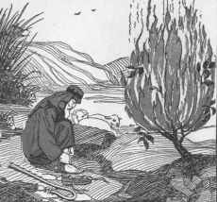

Process
This experience offers a simple introduction to contemplation including rationale, outline of simple practices and dispelling of some of the myths.

[Gospel of the day]
Optionally read but not for Ignatian engagement of insights

Rationale Religion has been the source of great good and great evil in the world throughout history. And most religions teach diverse ways of praying that are more or less helpful. Thought by many to be the most profound or transformative is that experience known under different titles such as contemplation or centering prayer.

Nature of the experience Contemplation is another way of being before God; to be deliberately present, aware, poised. It gets beyond emotions. It gets beyond the mind with its thoughts and images to something other but connected. It is NOT about talking to God or even ‘listening to God’ as did Joan of Arc in her imagination; or the process of lectio divina.

It is about deliberately but gently stilling the mind of thoughts and images to create ‘the vacuum’ into which the sacred may enter. The focus is not on emptying the mind of all thoughts, feelings, perceptions. They are natural and really can’t be got rid of. However, the intention is to be aware of these as they come in and to re-direct attention back to the sacred word, mantra, breathing. People need to be patient if they are to pursue this. If you are doing this with others, you may hear slight movement or sniffles or scratching. Or you may need to do these yourself – indeed, itches are quite common because of the loosening of spiritual or psychological ‘knots’. Remember that awareness is the key. Avoid overly disturbing another, but also avoid ‘trying to be still or silent’ and losing awareness.

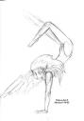

Benefits The ‘fruits’ of contemplation are infrequently experienced during that time of contemplation but rather seem to become mysterious expressed afterwards in attitudinal and behavioural responses. The practice requires discipline and some would even use the term ‘hard work’ to continue to attempt emptying the mind, again and again, bringing consciousness back to being and awareness only.
Many use a mantra with their breathing such as
- ‘Maranatha’ [= Come, Lord Jesus], or
- Jesu [pron Yay-zu] or
- Yah-weh
to return consciousness to awareness but ever so gently and patiently.


Not the aim While contemplation sometimes affords persons a deep sense of connection, awareness, beholding perhaps for 15-30secs or so, the pursuit of this is not the aim. It is NOT primarily to feel good or holy or connected though you may experience some of these things; pursuit of these as ends in themselves is a bit narcissistic or self indulgent and likely to end in disappointment and ‘illusion-ment’. Some understand much of the New Age spirituality to have this focus. The aim rather is persistent but gentle fidelity to the process on a regular basis with fruits borne in daily living afterwards.


Practice

Highly recommended practice:
- Sit erect, [not lie down] with feet flat on the floor and hands ready to receive.
- Eyes closed.
- Regular, deliberate breathing accepting every breath as gift.
- There may be a need to set an alarm to sound an end so as not to be distracted by waiting for this.

Final note: Prayer is the gift of God. While God is always available, accessible, wanting what is best for each of us, yet our own limitations, some recognised and some unknown, often act as a stumbling block or obstacle to this connection.

Prayer is God’s gift
Story best presented by pausing and reflecting on the next stage or response in the story as outlined in the questions.

GOOD NEWS

A story of two sons

Jesus began to teach in parables.
He said: The kingdom of god is like
two brothers who were called by God
to give up all they had and serve
humanity.

The older responded to the call though he
had to tear himself away from his fiancée
and his family and go off to a distant land
to spend himself in the service of the poor.
Years later he was imprisoned for his work,
tortured and put to death.

And the Lord said,
What? . . . Can you guess the message;
not the exact words of course?

“Well done my good and faithful servant! You
gave me a thousand measures of service. I shall
now give you a thousand million measures of beatitude.
Enter into the joy of your Lord”

The younger boy ignored the call. He married
the girl he loved and prospered in his business.

He was kind to his wife and children and gave
an occasional alms to the poor.

And when he came to die, the Lord said,
What? . . . Can you again guess the message?

“Well done my good and faithful servant! You gave me
twenty measures of service. I shall now give you a
thousand million measures of beatitude.
Enter in the joy of your Lord.”
!!! How can this make sense?

When the older by was told that his brother was to get
the same reward as he, he was surprised.
And he said what to the Lord?

The older boy rejoiced. “Lord,” he said,
“had I known this at the time you called me
I know I would have done exactly what I did for love of you.”

Reflections on Sole Ed – Bar Timaeus program
Most students did a reasonable job on completing the journal. This is considered important because we can too easily miss out on the richness of a significant experience unless we spend time with it and determine its learnings for us.

- You were given an outline of what the Sole Ed experience was about then Ian Healey spoke to you about the basics of what to expect and how to take care with those you were visiting. Name two or three feelings associated after this input? And what were your thoughts at that stage? [strange, uncomfortable, anxious, frightened, annoyed, looking forward to it, interesting, curious or just struggling to be at all involved]

……………………………………………………………………………………………………………………………….

……………………………………………………………………………………………………………………………….
- Students then volunteered for a particular centre to visit. What was the main factor/s in you selecting that venue and how satisfied are you now with that decision?

……………………………………………………………………………………………………………………………….

……………………………………………………………………………………………………………………………….
- What were the dominant feelings and thoughts as you approached the centre you were visiting the first time?

……………………………………………………………………………………………………………………………….

……………………………………………………………………………………………………………………………….
- Describe briefly your memory/ies from that first experience – what now stands out from during and/or straight after the encounter?

……………………………………………………………………………………………………………………………….

……………………………………………………………………………………………………………………………….
- How did you ‘process’ that first encounter – reflection; talking with mates, parents, other? How necessary or helpful or beneficial was/ were any of these?

……………………………………………………………………………………………………………………………….

……………………………………………………………………………………………………………………………….
- How did you approach and deal with subsequent visits – feelings, thoughts, learnings??

……………………………………………………………………………………………………………………………….

……………………………………………………………………………………………………………………………….
- What changes have there been at all to your principles, beliefs, values, attitudes? What is the most important thing you have learned?

……………………………………………………………………………………………………………………………….

……………………………………………………………………………………………………………………………….
- Who has benefited from your involvement and how – you, specific people you helped, staff or others that you can think of?

……………………………………………………………………………………………………………………………….

……………………………………………………………………………………………………………………………….

Sole Ed Trivia
Directions: In groups, go to nominated sections and subsections and retrieve and write all answers. You can use any strategy including team work to get these completed. However, all team members must be able to justify all answers.

- Rationale: Benefits are listed as accruing to students, ……………………, school and faculty.

- Rationale: What’s in a name? The title of the program refers to participants using their

two f……………., representing the balance of both structural and immediate helping with
the poor – a balance of both is needed to move forward.

- Rationale: Danger: What term is given to the attitude or condition where the contribution is all about me feeding my ego - to appear good and caring largely because I’m really not?
…………………………… ……….………………….

- Handbook functions: Which function # is about keeping a record of participation? ………..

- Principles and Procedures: Write the name of the principle which mentions the responsibility to protect the privacy of those ministered to or helped? …………………………

- Voluntary, out-of-school hours involvement: Just before the six point plan for planning your own Sole Ed experience, there are six checkpoints to be covered. Write the one

that is missing: rights, protocols, …………………….., supervision, safety, ‘banking’

- Sole Ed Program Awards: It is anticipated that there are to be three levels of achievement for these awards; a certificate, a laminated certificate then the highest being what given on a special Service Assembly the following year.
………….……..……

- Sole Ed Program Awards: Correct the one incorrect fact below. ‘Connection’ hours are:

- required over two years for the gold award of the Sole Ed Tie Pin …..…..
  - to represent at least 12.5hours of direct contact with person’s ……….
  - involved in activities either outside and within the College ……….
  - spent in either outside of school or inside school hours ……….

- Appendices: Which Appendix has a Sole Ed Activity record? ……….

- Appendices: Which Appendix is likely to outline basic rules and procedures to keep participants safe and acting responsibly
……….

Six Checkpoints to introducing your own voluntary Sole Ed experience.
So, you’ve had a really worthwhile learning experience or heard of those with the Bar Timaeus or Disciples 2 x2 program and now wish to extend yourself by structuring such an experience for yourself with some mates. This shows outstanding leadership from the very heart of Edmund Rice Education. It means that you are already, while still at school, considering following in the soles of Edmund Rice to liberate to live life to the full – the major vision of our College. The College celebrates this with the Sole Ed special awards annually. Criteria are outlined in the Sole Ed Program Awards section of this booklet.

How to start? There are six broad topics to be addressed. These include: Orientation and protocols, Transport, Safety, Supervision, Reflection, ‘Banking’.

The six point plan

- Decide for yourself [and with some friends] a worthwhile service experience.
- Contact the Dean of Mission to get approval for your involvement (very important) then the agency [with explicit DoM approval] if arrangements have yet to be made.
- Photocopy then complete all details of the Sole Ed Parent Letter & Validation Form [Appendix J] and submit. [Includes five points above ie Orientation, Transport . . .]
- Complete your journal after every session
- Complete and submit your Progress Forms as required incl Agency Report after your final session (Appendices A, C, D).
- Retain journal entries for assessment task in SoR or R&E.
 Remember this!

- DO NOT commence your project until you have signed approval from the Dean of Mission

- Students may register for projects specifically organised during school holidays. These will be adequately publicised through the daily bulletin, weekly newsletter and the intranet website.

St Laurence’s College
facere et docere
Senior Sole Ed Project Validation Form
Criteria for inclusion of a course
The criteria for a College-sanctioned service and/or solidarity-learning course?
The major criteria for designating a course as a Sole-Ed course at SLC are that it:
- addresses a genuine need in the community (campus, local, regional, global); do note the significance of connection hours for accreditation
- meets one or more course objectives
- demonstrates a clear connection between the service or solidarity activity and the course content
- involves reciprocity between course and community that results in students' increased communal awareness and engagement
- involves structured student reflection
- involves collaboration with an appropriate agency representative and parental mentors
- involves significant hours of student service to the community agency
Student Name ……………………………….. Year and HC ………………………………………
Activity proposal [for whom, doing what and why]
…………………………….…………………………………………………………………………………
…………………………….…………………………………………………………………………………
…………………………….…………………………………………………………………………………
- Venue, day, dates …………………………………………………………………………………………………………
- Protocols/ Orientation time ……………………………………… Mentor: …………………………………………
- Time and place to: meet …………………………………………… finish ……..………………………………………
- Transport there ……………………………………… Transport back …………………………………………
- Special clothing …………………………………………………………………………………………………………
- Reflection …………………………………………………………………………………………………………
- ‘Banking’ – how, who …………………………………………………………………………………………………………
Approved by DoM …………………………………………. Date ………………………..

