


IDENTITY OF THE CATHOLIC SCHOOL

A DISCUSSION PAPER FOR REFLECTION AND ACTION
Rationale

The purpose of this discussion paper is to identify characteristics that contribute to the identity of the Catholic school. It provides a framework and points of reference to assist school communities to reflect on their specifically Catholic identity. Schools may also use this material as a framework for auditing current practice and planning future action.

Context

This paper is written in response to a request from the Bishops of Queensland to the Queensland Catholic Education Commission. The paper constitutes part of a national conversation seeking to articulate the identity of the Catholic school in the twenty-first century. The document The Catholic School on the Threshold of the Third Millennium acknowledges that Catholic schools in the twenty-first century face challenges arising from their social, political and cultural context. Features of this context include crisis of values, relativism, pluralism, technological change, globalisation, multiculturalism, diversity of religious belief and the growing gap between rich and poor.



The document The Catholic School on the Threshold of the Third Millennium situates the Catholic school clearly within the mission and ministry of the Church:

“The complexity of the modern world makes it all the more
necessary to increase awareness of the ecclesial character of the
Catholic school. It is from its Catholic identity that the school
derives its original characteristics and its “structure” as a
genuine instrument of the Church, a place of real and
specific pastoral ministry. The Catholic school participates
in the evangelising mission of the Church and is a privileged
environment in which Christian education is carried out …
It is a true and proper ecclesial entity by reason of its
educational activity, “in which faith, culture and life are
brought into harmony”.
(The Catholic School On The Threshold of the Third Millennium, #11).

Factors that impinge on Australian Catholic schools as they seek to participate in the evangelising mission of the Church include:
- the explosion of knowledge
- competing and conflicting systems of meaning and value
- differences over approaches to teaching and learning
- the influence of the media
- the prominence of technology
- increasing influence of the political on education
- influence of commercial and economic factors on education
- education as a market driven enterprise
- religious and ethnic diversity in Catholic school communities
- varying degrees of affiliation with the Catholic Church
- diversity in religious knowledge and practice
- varying degrees of alienation from institutional religion
- a ‘smorgasbord’ of spiritualities
- generational differences in attitudes to life, learning, religion and spirituality
- changing patterns of family and family life
- increasing incidence of social/emotional/psychological dysfunction
- increasing relativism in relation to society, morality, meaning and truth

This discussion paper draws upon and is part of a wider conversation about Catholic school identity in contemporary societies. Specifically the focus of this paper is the ethos and identity of Catholic schools within an Australian educational context.

Two significant sources that inform this paper are:

The Queensland Catholic Bishops’ Research Project on Catholic Schooling and the subsequent focussing on the defining features of the Catholic school of the future that are articulated as follows:
The Catholic school of the future will:

- Have a strong Catholic identity and give witness to Christian values
- Be open and accessible to those who seek its values
- Offer a holistic curriculum
- Be a community of care and right relationships
- Be staffed by qualified, competent people who give witness to Gospel values

This paper uses the eight distinguishing features of Catholicism (Thomas Groome) to organise its material. The defining features of the Catholic school of the future from the Queensland Bishops Research Project on Catholic Schooling are then linked to Groome’s eight distinguishing features.

The works of Thomas Groome, What Makes a School Catholic (1996) and Education for Life (1998) that identify eight distinguishing features of Catholicism viz.
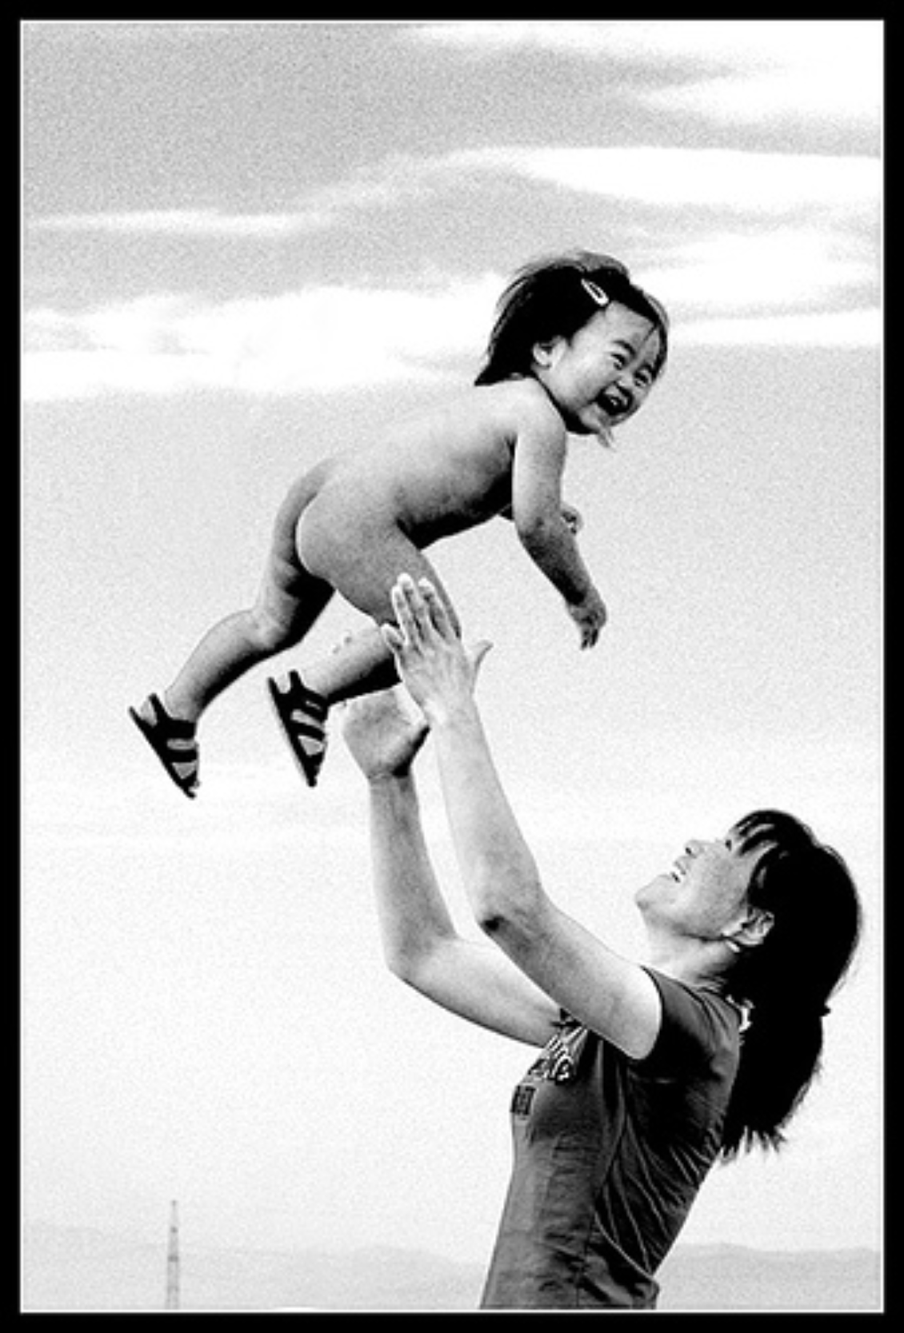
Positive Vision of the Person


Sacramentality

Com munity


Tradition


Spirituality for Everyone


A Faith that does Justice


A Reasoned Wisdom


Openness and Inclusion

Positive Vision of the Person

Defining Features of the Catholic School (Queensland Bishops)
- Be open and accessible to those who seek its values
- Be a community of care and right relationships
Focus
Our Catholic tradition affirms the inherent dignity of each human person created in the image and likeness of God. Catholicism has a realistic optimism that affirms love over hate, hope over despair, good over evil and justice over injustice. Each person has inherent rights and responsibilities as co-creators with God. The individual person is always both an individual self and yet turned toward “the other”; we are individual but communal, autonomous and relational, free and responsible.

Supporting the human dignity of all
A Catholic school recognises the inherent human dignity of each person .The school develops policies, practices and structures that protect and promote authentic freedom and human rights for each individual. School communities challenge each person to be accountable and to exercise their freedom in life giving ways.

Nurturing the gifts of each person
A Catholic school identifies and seeks to nurture and engage the giftedness of students, staff and parents for the good of the individuals and the community. The school recognises that the talents of individuals are a gift from God given for the service of others and the building up of the whole Body of Christ. School communities provide opportunities for each person and group to discover develop and celebrate their gifts.

Becoming a reconciling community
Catholic schools acknowledge that human individuals are essentially good but that sinfulness is part of the experience of each human person and of the communities in which they live. Therefore there is a need for forgiveness and reconciliation in every school community. Schools deal with failure in ways that promote growth and a hopeful vision for life.
For discussion and action

Where are we at present in supporting a positive vision of the human person?

Complete the scale below by circling one of the numbers. Your rating indicates your assessment of the reality of your school community at the present time.
1= Poor; 5 = Excellent

Supporting the human dignity of all

1 2 3 4 5

Nurturing the gifts of each person

1 2 3 4 5

Becoming a reconciling community

1 2 3 4 5

What initiatives might we take to better support a positive vision of the human person in our school community?

SACRAMENTALITY

Catholic sacramental understanding we live in a symbolic universe that acknowledges a deeper reality behind all experiences, from the Defining Features of the Catholic School (Queensland Bishops)
- Have a strong Catholic identity and give witness to Christian values

Focus
Our Catholic tradition has at its very core a sacramental vision of reality that experiences all created reality as permeated with the presence of God. In most mundane to the most exalted. In this sense Catholic understanding of sacramentality gives meaning and significance to all human experience. Catholic sacramentality has at its heart the Paschal Mystery, the life, death, and resurrection of Jesus Christ. The Paschal Mystery is the underlying pattern that connects us as Catholics to the story of Jesus and our life in the world.

Developing a sense of the sacredness of creation
A Catholic school develops a sense of the sacred when it attends to the aesthetic aspects of the school setting. The school identifies and fosters goodness and truth and promotes the aesthetic dimension of life. School communities nurture a sense of awe, wonder and respect for creation seeking to act in ways that are ecologically sustainable.

Connecting with symbol, story and tradition
A Catholic school engages with the Christian Story that embodies the life, death and resurrection of Jesus Christ. Each school community has a characteristic ethos and charism expressed in its symbols, values, stories and traditions. School communities seek a synthesis of their own particular symbols, values, stories and traditions with the symbols, values, stories and traditions of the larger Christian Story.

Celebrating liturgy and sacrament
Catholic schools celebrate in liturgy and sacrament the life of the Catholic Christian community of which they are one expression. Members of the school community are educated for authentic participation in the liturgical cycle of the Church. School communities develop creative, engaging celebrations of liturgy and sacrament that are faithful to the liturgical traditions of the Church.

For discussion and action

Where are we at present in promoting sacramentality in our school community?

Complete the scale below by circling one of the numbers. Your rating indicates your assessment of the reality of your school community at the present time.
1= Poor; 5 = Excellent

Developing a sense of the sacredness of creation

1 2 3 4 5

Connecting with symbol, story and tradition

1 2 3 4 5

Celebrating liturgy and sacrament

1 2 3 4 5

What initiatives might we take in our school community to better support a positive vision of the human person?

COMMUNITY

Defining Features of the Catholic School (Queensland Bishops)
- Have a strong Catholic identity and give witness to Christian values
- Be open and accessible to those who seek its values
- Be a community of care and right relationships

Focus
Catholic tradition gives particular prominence to community. Within Catholicism community is much more than a social reality. Community is also a theological reality focused on understandings of community as Communion, Body of Christ and People of God. Community is promoted through the development of right relationships and service of others. In community individuals gather for worship, hear and proclaim the Word of God and witness through their lives and service to others.

Fostering a sense of welcome and belonging
A Catholic school develops procedures and protocols that ensure that people are treated courteously and hospitably and made to feel welcome in the school community. A school community sustains and develops a sense of belonging when it models effective communication, fosters active participation, and celebrates of its life through prayer, liturgy and ritual. The school also provides opportunities its members to socialise with one another in a welcoming and inclusive atmosphere.

Building Christian community
A Catholic school builds Christian community through promoting in the curriculum and life of the school the Christian understanding of the Trinity that makes gives centrality to mutual relationship that reflect love as a creative reality that builds true communion among persons. When a school build Christian community individualism and selfishness is challenged and self giving and concern for the other is nurtured. Those working to build Christian community in a school challenge attitudes, actions and practices that cause division and alienation and strive to promote unity and engagement.

Acting for the common good
A Catholic school builds community when it discerns the common good in given contexts and works towards achieving that common good. Schools act for the common good when they promote the health and well being of all and practice mutual care and social responsibility. Schools act for the common good within the school community and in the wider society when they practice and educate for justice, peace and ecological sustainability.

For discussion and action

Where are we at present in promoting community in our school?

Complete the scale below by circling one of the numbers. Your rating indicates your assessment of the reality of your school community at the present time.
1= Poor; 5 = Excellent
Fostering a sense of welcome and belonging
1 2 3 4 5

Building Christian community

1 2 3 4 5

Acting for the common good

1 2 3 4 5

What initiatives might we take in our school to better support community?

TRADITION

Defining Features of the Catholic School (Queensland Bishops)
- Offer a holistic curriculum
- Be staffed by qualified competent people who give witness to Gospel values
- Have a strong Catholic identity and give witness to Christian values
Focus
Catholicism is a faith tradition that continues to journey in history. Catholics look to Scripture and its authoritative interpretation in the lived tradition of the Church as a source of guidance in their lives. Tradition emerges from the dialogue between culture and the Christian story in different historical periods. Tradition is a dynamic, living reality grounding Catholics in the wisdom of the past and shaping two thousand years of received wisdom to respond to present and future contexts.

Deepening understanding of the Catholic faith tradition
A Catholic school deepens understanding of the Catholic faith tradition in and through its Religious Education Program which is constructed, planned and taught, in an academically rigorous way using appropriate pedagogies,. Staff who teach religious education are appropriately qualified and accredited. The Catholic School gives priority to the teaching of religious education in making decisions relating to staffing and timetabling.

Critiquing culture from a Catholic faith perspective
The Catholic school does not pass on the tradition as a mere academic exercise. Its task is fundamentally “a synthesis of culture and faith and a synthesis of faith and life.” In carrying out this task the Catholic school provides a critique of its own cultural context in the light of the Gospel.

Promoting an ecumenical, inter-faith perspective
In deepening an understanding of the Catholic faith tradition the Catholic school engages ecumenically with people from various Christian Churches and with people from faith traditions other than Christian. It does this through its educational programmes. Many Catholic schools enrol students and employ staff from various Christian Churches and from faith traditions other than Christian. While the Catholic ethos of the school is maintained, respectful dialogue is promoted between all members of the school community.

For discussion and action

Where are we at present in promoting sacramentality in our school community?

Complete the scale below by circling one of the numbers. Your rating indicates your assessment of the reality of your school community at the present time.
1= Poor; 5 = Excellent

Deepening understanding of the Catholic faith tradition

1 2 3 4 5

Critiquing culture from a Catholic faith perspective

1 2 3 4 5

Promoting an ecumenical, inter-faith perspective

1 2 3 4 5

What initiatives might we take in our school community to promote a deepened appreciation of the Catholic faith tradition?
A REASONED WISDOM

Defining Features of the Catholic School (Queensland Bishops)

- Offer a holistic curriculum
- Be staffed by qualified, competent people who give witness to Gospel values

Focus
Catholicism has had a long and rich tradition of seeking to establish truth through rational processes in the light of scripture and tradition. A well-known definition of theology is “faith seeking understanding”. Thus, Catholicism values highly rationality and all types of knowledge. Catholicism recognises both the value as well as the limits of reason in the search for truth.

Facilitating a genuine search for truth
Catholic schools design, review and develop learning areas of the curriculum to promote critical thinking, sound reasoning and academic excellence. Schools nurture a genuine search for truth in their students as they engage with the diverse learning areas of the curriculum. The school develops curriculum that is intellectually challenging and promotes effective teaching and learning.

Adopting effective approaches to learning and teaching
Schools scaffold and structure learning tasks in the learning areas of the curriculum in ways that enhance the thinking and reasoning skills of students. School communities design engaging and focused assessment tasks to assess and monitor the knowledge, understanding and skills of students and inform the ongoing learning process.

Providing resources to develop reflective self directed learners
Schools ensure that resources developed for learning and teaching integrate elements that provide for reflection by both students and teachers on what is being learned and its significance. The school provides opportunities for reflection upon, and acknowledgment of, significant learning through prayer, liturgy, ritual and social gathering and celebration.

For discussion and action

Where are we at present in promoting a reasoned wisdom in our school community?

Complete the scale below by circling one of the numbers. Your rating indicates your assessment of the reality of your school community at the present time.
1= Poor; 5 = Excellent

Facilitating a genuine search for truth
1 2 3 4 5

Adopting effective approaches to learning and teaching
1 2 3 4 5

Providing resources to develop reflective self directed learners

1 2 3 4 5

What initiatives might we take in our school community to promote a reasoned wisdom?

A SPIRITUALITY FOR EVERYONE

Defining Features of the Catholic School (Queensland Bishops)

- have a strong Catholic identity and give witness to Christian values
- Be open and accessible to those who seek its values
- Offer a holistic curriculum

Focus
The Catholic faith tradition has given rise to a wealth of expressions of spirituality in diverse historical and cultural contexts. For Catholics, spirituality is relational connecting the individual to God, to life, to persons and to all creation. The Catholic tradition has valued both individual and communal expressions of spirituality. Spirituality has its source in a sense of awe and wonder at the mystery of life. Spirituality is nurtured through prayer, meditation, contemplation, asceticism, religious practice and action.

Nurturing the faith growth of individuals and groups
The Catholic school through formal and informal prayer, its academic programmes, its communal life, and in celebrating its life as a Catholic educational community, intentionally seeks to nurture the faith life each person and of the community. Quality relationships are of prime concern and include each person’s relationship with God; relationships within the community; relationships with families, with the faith community, with the wider community; and the whole of creation. It is in and through these relationships that the faith life of individuals and groups grows and is nurtured.

Connecting spirituality with the Catholic faith tradition
The Catholic school draws on the riches of the Catholic faith tradition in nurturing the spirituality of each person and of the whole community. Its educational programs teach about the many spiritual traditions that have emerged within Catholic Christianity. It also provides experiences of these traditions through formal and informal prayer and in retreat programs. The Catholic school also interacts with the wider faith community and the parish or parishes from which it draws its students.

Developing a spirituality that leads to action
The Catholic spiritual tradition finds expression in a deepening relationship between each person and God and, in outreach to all and especially to the poor and marginalised, who are the “face of God” for members of the Church. The Catholic school provides opportunities for its members to be well informed about situations of disadvantage in the world, to critique these situations in the light of the Gospel, and to become involved in outreach experiences such as fund raising, immersion programmes and social justice activities.

For discussion and action

Where are we at present in promoting a spirituality for everyone in our school community?

Complete the scale below by circling one of the numbers. Your rating indicates your assessment of the reality of your school community at the present time.
1= Poor; 5 = Excellent

Nurturing the faith growth of individuals and groups

1 2 3 4 5

Connecting spirituality with the Catholic faith tradition
1 2 3 4 5

Developing a spirituality that leads to action

1 2 3 4 5

What initiatives might we take in our school community to promote spirituality for everyone?

A FAITH THAT DOES JUSTICE

Defining Features of the Catholic School (Queensland Bishops)

- Be experienced as a community of care
- Promote the dynamic vision of God’s love

Focus
At the heart of Catholic social teaching is recognition of the intrinsic value of each person and the whole of creation. Catholics recognise that faithfulness to the Gospel of Jesus Christ entails recognising and acting upon a ‘fundamental option for the poor. Action for social justice aims at restoring and promoting ‘right relationship’ within the created order.

Developing understanding of Catholic social teaching
A school integrates Catholic social teaching across the learning areas of the curriculum. The school designs and implements the learning areas of the curriculum in ways that promote understanding of and action for justice, peace and ecological sustainability

Promoting justice within the school community
A school ensures that all policies, procedures and structures within the school draw upon Catholic social teaching and encourage action for justice within the in harmony with this teaching. The school promotes attitudes and ways of acting that respects the dignity of each individual and positively values and engages social, cultural and religious diversity within the community of the school.

Acting for justice in the world
The school develops in both students and staff sensitivity to authentic human and social values derived from Catholic social teaching. Schools promote awareness of injustice in society and the wider world and encourage students and staff to participate in action for justice. The school endeavours to nurture an attitude of hope based on Christian realism in relation to the struggle for justice in the world.

For discussion and action

Where are we at present in promoting a faith that does justice in our school community?

Complete the scale below by circling one of the numbers. Your rating indicates your assessment of the reality of your school community at the present time.
1= Poor; 5 = Excellent

Developing understanding of Catholic social teaching

1 2 3 4 5

Promoting justice within the school community
1 2 3 4 5

Acting for justice in the world

1 2 3 4 5

What initiatives might we take in our school community to promote a faith that does justice?

OPENNESS AND INCLUSION

Defining Features of the Catholic School (Queensland Bishops)

- Have a strong Catholic identity and give witness to Christian values
- Be open and accessible to those who seek its values
- Be a community of care and right relationships

Focus

The word ‘catholic’ (Greek-kata holou) means ‘embracing the whole’. Thus openness and inclusion are fundamental to what it means to be Catholic. These same values of ‘openness’ and ‘inclusion’ lie at the very heart of the ministry of Jesus. Gospel hospitality and welcoming of the stranger are intrinsic characteristics of communities that bear the name ‘catholic’.

Developing inclusive policies, practices and structures
The Catholic school is especially mindful of equity issues and of the many ways in which individuals and groups can be excluded by, and marginalised within, organisations such as schools. Processes are established that allow for ongoing review and redress of inequities of access and success. The school seeks openness and humility so that inequity can be addressed in a timely and compassionate way.

Promoting dialogue, participation and partnership
The Catholic school seeks to create an open and inclusive community. Catholic schools are not private schools but seek the common good through openness to all who share the school’s vision and values as a catholic school. Parents are acknowledged as the first and prime educators of their children and schools ensure that parents are respected and supported in this crucial role. The school also engages with other educational communities forming networks of learning.

Creating flexible learning environments
The Catholic school is mindful of the diverse ways in which students learn. It creates learning environments that are flexible and attuned to the preferred learning styles of its students. Teachers engage with professional learning experiences that keep them updated on new understandings of how students learn and ways of creating learning environments to meet the diversity within each classroom.

For discussion and action

Where are we at present in promoting openness and inclusion in our school community?

Complete the scale below by circling one of the numbers. Your rating indicates your assessment of the reality of your school community at the present time.
1= Poor; 5 = Excellent

Developing inclusive policies, practices and structures

1 2 3 4 5

Promoting dialogue, participation and partnership
1 2 3 4 5

Creating flexible learning environments

1 2 3 4 5

What initiatives might we take in our school community to openness and inclusion?

