ACKNOWLEDGMENT

This Retreat Program is part of a greater number of documents which have been generously supplied by a small number of schools prepared to share their resources and ideas with other schools for the benefit of students elsewhere.

This site is a growing space: If you find some of the ideas helpful, it would be wonderful if you could include your retreat/s in the Religious Education Leaders Collaborative Space.

Special thanks go to for submitting these initial retreats:

Dana Wedge (St John Fisher College, Bracken Ridge)
Paul Towler (St Laurence’s College, South Brisbane)
Sandra Allen (Clairvaux-McKillop College, Mt Gravatt)
Jenny Cross (South Burnett Catholic College)
Alison Stone (Mt Alvernia College, Kedron)
Carmel O’Brien (Unity College, Caloundra)

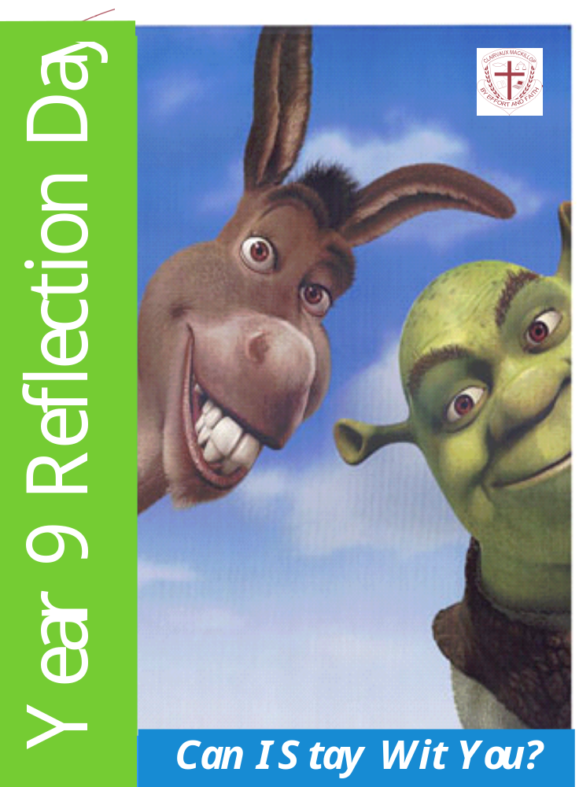

Year 9 Reflection Day 2008

Written by Sandra Allen (Clairvaux MacKillop College ) and Majella Allen (Mt Maria College)
Based on the movie “”Shrek 1”

Session 1 8.40am – 10.30am
8.40 – 9.00 Walk to Showgrounds
9.00 – 9.15 Expectations, Housekeeping
9:15 – 9.45 Melodrama – “If Only I Had A Green Nose.”
9.45 – 10.45 “Can I Come Wit You”
- Shrek Scene 2 – 5mins
- Making a Friendship Doll
- PPT Reflection “A-Z of Friendship”. – 5mins

Morning Tea 10.45 – 11.15am

Session 2 11.15 – 12.40
11.15 – 11.20 Onion Chin Relay
11.10 – 12.40 “Ogres are Like Onions”
- Shrek Scene 6
- Handout “I Have Layers”
- Labels Scenario
- Collected Wisdom of Year 9
- Shrek Scene 4
- Debrief

Lunch 12.40 - 1.30

Session 3 1.30 – 2.45
1.30 –1.35 “Oh No! Not My Gumdrop Buttons”
1.35 – 2.05 “Seeing Others”
2.05 – 2.30 “Culminating Ritual
2.30 – 2.50 Evaluation & Clean Up

Reflection Day Team
Staff: Monday Sandra Allen, Peter Orton, Leona Pearson
Tuesday Sandra Allen, Ed Lai, Rebecca Ingram
Wednesday Liesl Profke, Peter Orton, Leona Pearson
Thursday Liesl Profke ,Ed Lai, Donna Paichl
Friday Liesl Profke, Rebecca Ingram, M Ruigrok


Activity One
Whole Group/ 15minutes – Sandra Allen
Resources: White Board Pen/Poster

INTRODUCTION TO RETREAT
- Outline “Reflection Day” experience;
- Identify expectations for behaviour;
- Outline structure and program for the day;

Activity Two
Whole Group/30 minutes

“IF ONLY I HAD GREEN NOSE” – A MELODRAMA
Based on the book “If Only I Had a Green Nose” by Max Lucado

Characters
Punchinello, Trip, Splint, Twiggy, Willy Withit, Bertha Bigbritches, Eli,
Townspeople (the audience)

PROPS
Signs: Clock; Nose-Painting Store; Downtown (with arrow); Eli’s Workshop.
Face paints – green, red, blue, yellow
Scarf for Bertha. Sunnies for Willy.
A sheet to serve as the nose-painting store.

Narrator
Welcome to the wonderful town of Wemmicksville, where everyone is a wooden person. Everyone was carved by Eli, the woodcarver, and all live in the same village. On your right, you’ll see our hero, Punchinello, and his friends, Trip and Splint. Say hi guys.
It’s Saturday morning and Punchinello and his friends have been skipping happily around in downtown Wemmicksville. They love skipping. Look at their happy faces. They also like to hop. They looove to hop. Hop hop hop.
All of a sudden, they stop their merry games and freeze in utter shock and horror. Willy Within, the coolest and most popular guy in town is waltzing towards them with a very green nose and a very big smile on his face.
“What’s happened to your nose, Willy?” Punchinello shrieks.
“Don’t you know?” Willy yells back. “Why, it’s the latest trend in Wemmicksville.”
At this moment, Bertha Bigbritches comes bouncing up to them with a very green nose and a very big grin.
Punchinello and his friends look at them in utter amazement. Their jaws drop open, and their eyes nearly pop out of their heads.
“Seeya round, Wooden-nosers” sing Willy and Bertha as they skip merrily off, hand in hand.
Punchinello and his friends look at each other with very sad faces.
“We’re not with it” sobs Trip.
“We’re not green-nosed” bawls Splint.
They walk around like old men. Trip trips over.
Their faces brightened up when they see a nose-painting shop.
They quickly tiptoe inside.
A few moments later, they emerge with very green noses.
They strike a body builder’s pose.
The townspeople go mad! They clap and stomp and whistle like crazy.
Time passes.
The next morning, Punchinello and his friends were again leaping around downtown, with their very cool green noses in the air.
Suddenly, they stop right where they are and freeze in horror.
Willy Withit is prancing past them with his nose in the air – and it is RED!
Punchinello and his friends throw themselves on the ground in grief, sobbing and howling.
They then leap into the air and rush madly to the nose-painting store.
A few moments later, they all moonwalk out of the store with their red noses up in the air.
The townspeople go wild!
Time passes.
Punchinello and his friends are swaying around downtown.
Suddenly, they freeze in horror!
Bertha Big britches is standing across the street, giggling at Punchinello and his friends – and she has a BLUE nose! Punchinello and his friends began sobbing and tearing out their hair.
They turn and run like gorillas back to the nose-painting store.
A few moments later, they moshed out of the store with blue noses.
They strike a pose like ballerinas
The audience goes wild!
“Huzzah” Punchinello and his friends bellow.
Suddenly, they all freeze in complete shock.
Twiggy, one of their best friends (and hottest girl in Wemmicksville) is sashaying towards them with her nose in the air – and it is YELLOW!
“Guys, what are you doing with blue noses?” she squeaks. “That is sooo 2 minutes ago”
Punchinello and his friends drop to the ground in utter devastation.
They howl, they moan, they sob and wipe their noses on their sleeves.
“Face it dudes” bawls Punchinello. “The only thing we can do now is go see Eli.” he moans.
“Eli?” the other two shriek. “No way!” they yell. They get up and scamper off.
Punchinello sighs. He struggles to his feet and walks very sadly up the hill towards Eli’s workshop.
Eli sees him coming and rushes out to meet him. He looks very closely at Punchinello’s nose.
“Been trying to fit in, eh?” Eli says.
Punchinello nods in a very sad way.
“Did it work?” Eli asks him.
“Nuh.” Punchinello shrugs. “Every time we got close, the rules were changed.” he explained.
Punchinello puts on his thinking face.
“Can you help me to be myself again?” he asks quietly.
“Of course I can” Eli bellows. He puts his hand on Punchinello’s small shoulder.
I’ll always help you to be who I made you to be” he tells him.
Then he whips out a piece of sandpaper from his pocket. “But this may take some time…hold still.” Eli warns Punchinello.
And so, this story ends with Punchinello following Eli into his workshop, where they spend most of the day hanging out and removing paint. It hurt to be sanded, but it was worth it to be normal again.
And the townspeople went wilder than ever before.

Debriefing
- Description - Ask one student to start telling the story in their own words. Another takes over. Continue until the whole story is told. This will highlight different perspectives.
- So What? - What sort of person do you think Willy Withit was? What stood out to you about Punchinello?
Why do you think Punchinello kept changing to be the same as Willy?
What do you think about Eli? What kind of friend is he?
- Now What? Does this relate in any way to situations you find yourself in? Have you ever been a Willy Withit? Have you ever been a Punchinello? Have you ever been an Eli?

Activity Four
Whole Group/ 5 minutes
Resources: DVD Shrek

Shrek Scene 2 (I’ll Stay Wit You)

Activity Five
Small Groups/ 55 minutes
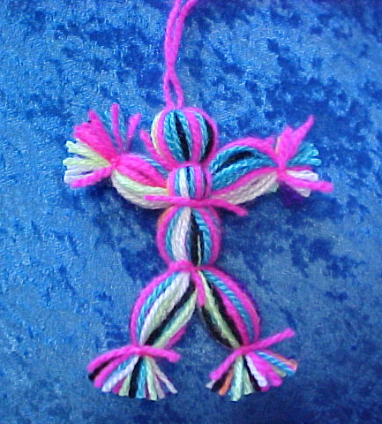
Resources – Wool, scissors.

Friendship Dolls
Each doll is made up of 42 strands of wool. Each strange represents symbolically qualities and values that we seek in our friendships. (Instructions on powerpoint).

Activity Seven
Whole Group/ 5 minutes

PPT Reflection – “A – Z of Friendship”



Activity One
Whole Group/15 minutes
Resources: 4 onions.
Ice Breaker – Onion Chin Relay
  - Four teams line up from the bottom of the auditorium stairs to the top.
  - Each team has an onion.
  - The onion is passed from under one chin to another without using hands.

Activity Two
Whole Group/5 minutes
Shrek, Scene 6 (Ogres are like Onions)

Activity Three
Individual/15 minutes
Resources: Hand out “I have Layers”
“I Have Layers”

Activity Four
Whole Group/25 minutes
Resources: Labels, Pens.
Labels Scenarios
a) Students are ask about the labels they’ve heard or used. As they are calling these out Staff write these on the sticky labels.
- Students are then asked to sit in rows facing forward in front of their Group Leader. They are not allowed to turn around. When they are ask to begin the activity they aren’t allowed to tell the other students what label has been placed on their forehead. This will lead to disqualification.
- The group leader then places label on forehead of each students. (homeless, ugly, fat, rich, poor, uncool, skank, dumb, smart, sporty, blond, freak, goth, emo, loner, teacher’s pet, class clown, black, popular, cool, hottie, loud-mouth, gay, bitch) If you’ve guessed your label don’t ask others if you’re right.
- Invite them to stand and begin to interact with the group. They have to walk around speaking to at least five people and reacting to people as if they are the label on their forehead.

- Debrief
Part 1
Briefly explain about labels that we give people.
“One of the most common terms used by young people to describe others is “loser”. That’s not a description of someone. It’s a label. Can you give some examples of the other labels you’ve heard used or you’ve used yourself. (nerd, gay, racist, stupid, skank, loud-mouth, show-off, bitch, snob etc)”.

Part 2
- Objective: Ask student who had guessed their label. What did people say or do that made you guess who you were? (Implications – people don’t usually call you the label right out)
- Reflective: How did this make you feel?
- Interpretive: Why do you think you felt this way?

Activity Five
Small Group/25 minutes
Resources: Poster Paper, Pens, Blue Tac
“Labelling – Collected Wisdom of Year 9’s.”

- Small groups 1 – 3 discuss “Reasons why we resort to the labelling of others?”
Small groups 4 - 6 discuss “Reasons why we accept the labelling of others?”

Have a spokesperson from each group present this to the whole group.

b) Debrief Collected Wisdom (PPT)
Incorporating the Collected Wisdom ask students questions around the following reasons used to labelling.
- We think it gives us more power—we use it to control others;
What evidence do we have that calling someone a label gives us more power?
- We think we’re funny;
Challenge that assumption. It may appear that you’re funny but you’re being mean to be funny.
- We put others down to make ourselves look better.
- We believe the label is true.
What do you think would happen if there was truth in the label and you kept calling someone by that label? Negative ones penetrate to your core until you believe it.
- We believe we have the right.
What assumptions are we making here? Natural to categorise but the problem is when we stop there – 5 year old see Fat won’t see unhappy Peel back the layers the labels are stripped off.

- It may be due to carelessness and bad habits.
It’s unhealthy and a sign of immaturity if you don’t develop the ability to see beyond the label because not only does it isolated people from you, it also isolates you from other people. Immature not to be able to expand your mental capacity to see more.

- Whether we agree with them or not, we may accept labels to remain part of the ‘in’ crowd.
What of we afraid of in this situation.
- We may not be assertive enough to come to the defence of others. Happy but sad at the core

Think/ Pair/ Share:
- When have you made an assumption on someone based on first impressions that turned out to be wrong?

- Can you think of a time when you either initiated labelling or joined in or let it happen?

- Why did you do it? Or why did you join in? Or why did you accept it.

- How can we translate this to real life? Now that you have experienced what it’s like to be labelled what does this mean in your life. Knowing these things what does this mean in our life?



Activity One
Whole Group/5 minutes

“Not My Gumdrop Buttons”- Shrek, Scene 4

Activity Two
Whole Group/25 minutes
Resources: Handout Slips “I feel…..”
“Seeing Others”
- Story of “Sonia” – Sandra

- “Introduce making reference to Lord Farquar and how he treated the gingerbread man. It comes down to how we “see others”. When you see new people do you see them as: Intruders? Possible Enemies? Possible Friends?
Seeing Others As Invisible—It’s possible to go through life not “seeing” other people at all. We can focus so much on ourselves that we become all that we can see! Other people fade into the back ground and become invisible.
Seeing Others As Things—We can also go through life looking at people but not actually seeing them as people. We see them as “things” that we can use and control for ourselves.
Seeing Others As Smaller—There are also times when we may see other people as smaller than ourselves.
We spend our time looking down on people for all sorts of reasons. This may be because….
they don’t look like us, they don’t sound like us, they don’t dress like us, they don’t act like us,…
but whatever the reason, on these occasion we see others as less important and less valuable than ourselves.”

- Distribute two pieces of construction paper (20cms x 3cms) to each student. Invite students to complete the sentence “I feel invisible, less valuable or used when……….” on one sheet. On the other sheet complete the sentence “ I might cause people to feel invisible, less valuable or used when I ………..”

- Collect these from students and read out.

- Invite students to reflect on one thing that they can do to make a difference. They will make a public declaration of this action in the culminating ritual.

- Make handcuffs out of the strips. Form a circle of one strip and staple. Thread the other strip through the first strip and staple. These handcuffs will be used for the ritual.

Activity Three
Whole Group/25 minutes.
Resources: Candle, Slips, Music – ‘Ugly’, Lectionery, Hand-cuffs
Direct students to sit in a circle.

The Gathering: Light Candle and invite students to be silent and listen.
Play “Ugly” by the Sugar Babe. (PPT)

The Reading: “On the Sabbath day Jesus went into the synagogue as he usually did.
And he stood up to read.
The scroll of the prophet Isaiah was handed to him.
He unrolled it and found the right place. There it is written,

‘The Spirit of the Lord is on me.
He has anointed me
To tell the good news to poor people.
He has sent me to announce freedom for prisoners.
He has sent me so that the blind will se again.
He wants me to free those who are treated badly.
And he has sent me to announce the year when he will set his people free.”’

The Good News of Jesus the Christ.

The Telling:

Jesus proclaimed release to captives and brought sight to the blind. He proclaimed a radical reversal! The first shall be last and the last shall be first. This meant that those who were least were empowered for new life. This is how he used his power to heal not to dominate. Because God is about mending creation and we are invited into this process.

Where ever, whenever God’s household is here it’s welcomed in a healed body, in a mind that is restored, in a more just school, in a heart that finds the power to forgive. Who’ll know if God has been here. The bullied will know if justice is being done and if creation is being mended. It’s not that the bullied are more important then the bully. It’s just that welcoming people who are outcast, on the outside, is a sign of God’s presence in our midst.

Listen today to the call to all people of goodwill to build a more just and compassionate Year 8 household. Will you commit to the struggle for a Year Level where no one is left out or pushed out. Will there be a cost in standing up? Yes, I think so. Jesus always took the side of the outsider: in his day it was women, sinners, people of other races – Samaritans etc. He stood up and confronted the unjust power of his day that kept people captive in racism etc and was nailed on a cross for it. But by his action he empowered us to faith and new life and the ability to be a partner in a new reality.

Your tasks is to make a stand against unjust and hurtful power. The building of a better Year 9 life needs you to stand up and speak out in a united voice so that people who are pushed out are brought back in. I can’t think of a better description of a life well lived. Will you stand up?

The Choosing: Have each person thread one link of the bracelet on their right wrist. Have the person sitting on their right thread their left hand through the other link of the bracelet. The result should be a paper chain linking everyone, wrist to wrist, around the circle.

Invite the group to reflect on the symbolism of the chains that bind them together. Comment that the chains represent the effects of personal injustice, from which no one is spared. We have all been victims of injustice. We have also committed acts of injustice at some time in our life. The chains reveal the truth that when one person is oppressed, we are all oppressed.
Comment that Jesus gives us the power to break the chains of injustice by forgiving others and reaching out.

Invite each person to stand up, in turn, and make their public declaration. As they stand up and reach out with hands outstretched, palms facing up the paper chains will break each time a participant stands, until eventually the whole group is free.

The Closing: Conclude the ritual with the Lord’s Prayer. At the end, repeat the line “and forgive us our sins, as we forgive those who sin against us.” Remind students that because they have been forgiven the injustices they have committed, they have received the spirit of forgiveness, which allows them to forgive those who have hurt them and to reach out to others who are hurting.

The Blessing:
Lord, grant that we may: Have eyes that see,
Have heart that understand
Have courage to give
Have strength to hope
Have openness to receive
Have seriousness to be silent
Have depth to think
Have concern to care
Have desire to search
Open our minds and our hearts from this day forward
That we may receive the precious things that you are waiting to give in Jesus name. Amen.

Skrek “But You Are Beautiful” Scene 17

Activity Four
Whole Group/15 minutes
Resources: Evaluation and pens.
Evaluation & Clean up

“On the Sabbath day Jesus went into the synagogue as he usually did.
And he stood up to read.
The scroll of the prophet Isaiah was handed to him.
He unrolled it and found the right place.
There it is written,

‘The Spirit of the Lord is on me.
He has anointed me
To tell the good news to poor people.
He has sent me to announce freedom for prisoners.
He has sent me so that the blind will se again.
He wants me to free those who are treated badly.
And he has sent me to announce the year when he will set his people free.”’

The Good News of Jesus the Christ.

